**UNIVERSITY OF VISVESVARYA COLLEGE OF ENGINEERING**

*K R Circle – 560 001*

**DATABASE MANAGEMENT SYSTEM MANUAL**

|  |  |  |
| --- | --- | --- |
| **SL no.** | **Databse** | **Page no.** |
| **1** | **Library Database** | **2-5** |
| **2** | **Sales Order Database** | **6-9** |
| **3** | **Movie Database** | **10-13** |
| **4** | **College Database** | **14-18** |
| **5** | **Company Database** | **19-23** |

**Submitted by:**

Arshan A Shaik – U25UV22T006005

Kushal sathwik– U25UV22T0060

**Signature:**

**Dr. Samyama Gunjal G H**

_________________________

**1) LIBRARY DATABASE**

## DDL (Data Defination Language)

CREATE TABLE BOOK (

Book_id INT,

Title VARCHAR(200),

Publisher_Name VARCHAR(100),

Pub_Year YEAR

);

CREATE TABLE BOOK_AUTHORS (

Book_id INT,

Author_Name VARCHAR(100)

);

CREATE TABLE PUBLISHER (

Pub_id INT,

Name VARCHAR(100),

Address VARCHAR(200),

Phone VARCHAR(15)

);

CREATE TABLE BOOK_COPIES (

Book_id INT,

Branch_id INT,

No_of_Copies INT

);

CREATE TABLE BOOK_LENDING (

Book_id INT,

Branch_id INT,

Card_No INT,

Date_Out DATE,

Due_Date DATE

);

CREATE TABLE LIBRARY_BRANCH (

Branch_id INT,

Branch_Name VARCHAR(100),

Address VARCHAR(200)

);

lter table book

add constraint book_keysff primary key(book_id);

ALTER TABLE BOOK_AUTHORS

ADD CONSTRAINT PK_BOOK_AUTHORS PRIMARY KEY (Book_id, Author_Name);

ALTER TABLE PUBLISHER

ADD CONSTRAINT PK_PUBLISHER PRIMARY KEY (Pub_id);

ALTER TABLE BOOK_COPIES

ADD CONSTRAINT PK_BOOK_COPIES PRIMARY KEY (Book_id, Branch_id);

ALTER TABLE BOOK_LENDING

ADD CONSTRAINT PK_BOOK_LENDING PRIMARY KEY (Book_id, Branch_id, Card_No);

ALTER TABLE LIBRARY_BRANCH

ADD CONSTRAINT PK_LIBRARY_BRANCH PRIMARY KEY (Branch_id);

#add foregin key constrainst

alter table publisher

add constraint fk_pubslishercss foreign key(publisher_name) references publisher (name);

ALTER TABLE BOOK_AUTHORS

ADD CONSTRAINT FK_BOOK_AUTHORS_BOOK FOREIGN KEY (Book_id) REFERENCES BOOK(Book_id);

ALTER TABLE BOOK_COPIES

ADD CONSTRAINT FK_BOOK_COPIES_BOOK FOREIGN KEY (Book_id) REFERENCES BOOK(Book_id);

ALTER TABLE BOOK_COPIES

ADD CONSTRAINT FK_BOOK_COPIES_BRANCH FOREIGN KEY (Branch_id) REFERENCES LIBRARY_BRANCH(Branch_id);

ALTER TABLE BOOK_LENDING

ADD CONSTRAINT FK_BOOK_LENDING_BOOK FOREIGN KEY (Book_id) REFERENCES BOOK(Book_id);

ALTER TABLE BOOK_LENDING

ADD CONSTRAINT FK_BOOK_LENDING_BRANCH FOREIGN KEY (Branch_id) REFERENCES LIBRARY_BRANCH(Branch_id);

## Data Manipulation Language (Inserting tuples)

INSERT INTO BOOK VALUES

(1, 'Database Systems', 'Pearson', 2018),

(2, 'Operating Systems', 'McGraw Hill', 2019),

(3, 'Computer Networks', 'Pearson', 2020),

(4, 'Data Structures', 'O Reilly', 2017),

(5, 'Machine Learning', 'Springer', 2021),

(8, 'Machine Learning', 'Springer', 2021);

INSERT INTO PUBLISHER VALUES

(101, 'Pearson', 'New York', '1234567890'),

(102, 'McGraw Hill', 'Chicago', '2345678901'),

(103, 'O Reilly', 'San Francisco', '3456789012'),

(104, 'Springer', 'Berlin', '4567890123'),

(105, 'Elsevier', 'London', '5678901234');

INSERT INTO BOOK_AUTHORS VALUES

(1, 'Korth'),

(2, 'Silberschatz'),

(3, 'Tanenbaum'),

(4, 'Mark Allen Weiss'),

(5, 'Tom Mitchell');

INSERT INTO LIBRARY_BRANCH VALUES

(10, 'Central Library', 'Main Street'),

(11, 'Science Block', 'North Wing'),

(12, 'Engineering Block', 'East Wing'),

(13, 'IT Block', 'South Wing'),

(14, 'Management Block', 'West Wing');

INSERT INTO BOOK_COPIES VALUES

(1, 10, 5),

(2, 11, 3),

(3, 12, 4),

(4, 13, 2),

(5, 14, 6);

truncate book_lending;

TRUNCATE TABLE BOOK_LENDING;

INSERT INTO BOOK_LENDING VALUES

(1, 10, 1001, '2025-01-10', '2025-01-24'),

(2, 11, 1001, '2025-02-15', '2025-03-01'),

(3, 12, 1001, '2025-03-01', '2025-03-15'),

(4, 13, 1001, '2025-04-05', '2025-04-19'),

(5, 11, 1002, '2025-01-12', '2025-01-26'),

(2, 11, 1002, '2025-02-18', '2025-03-04'),

(3, 12, 1002, '2025-03-10', '2025-03-24'),

(4, 13, 1002, '2025-04-12', '2025-04-26'),

(5, 14, 1002, '2025-05-15', '2025-05-29'),

(3, 12, 1003, '2025-03-05', '2025-03-19'),

(4, 13, 1004, '2025-03-07', '2025-03-21'),

(5, 14, 1005, '2025-03-09', '2025-03-23');

## QUIERES

1. **Retrieve details of the books in the library: id, title, name of the publisher, authors, number of**

**copies in each branch, etc.**

SELECT B.Book_id,

B.Title,

B.Publisher_Name,

A.Author_Name,

C.Branch_id,

C.No_of_Copies

FROM BOOK B

JOIN BOOK_AUTHORS A ON B.Book_id = A.Book_id

JOIN BOOK_COPIES C ON B.Book_id = C.Book_id;

select * from book_lending;

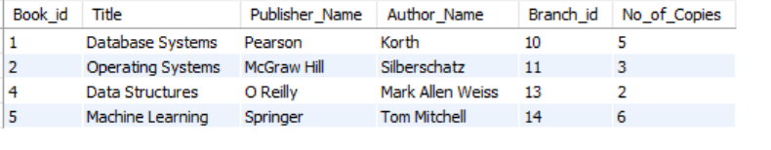

1. **Get the particulars of the borrowers who have borrowed more than 3 books from Jan 2019 to Jun**

**2019**

SELECT Card_No, COUNT(*) AS Total_Books_Borrowed

FROM BOOK_LENDING

WHERE Date_Out BETWEEN '2025-01-01' AND '2025-06-30'

GROUP BY Card_No

HAVING COUNT(*) > 3;

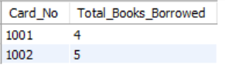

1. **Delete a book in BOOK table and update the contents of other tables to reflect this data manipulation operation**

#step1: enable cascade while declaring foreign key This way, deleting a book from

# BOOK will automatically delete related records from other tables

ALTER TABLE BOOK_AUTHORS

ADD CONSTRAINT FK_BOOK_AUTHORS_BOOK FOREIGN KEY (Book_id) REFERENCES BOOK(Book_id) ON DELETE CASCADE;

ALTER TABLE BOOK_COPIES

ADD CONSTRAINT FK_BOOK_COPIES_BOOK FOREIGN KEY (Book_id) REFERENCES BOOK(Book_id) ON DELETE CASCADE;

ALTER TABLE BOOK_LENDING

ADD CONSTRAINT FK_BOOK_LENDING_BOOK FOREIGN KEY (Book_id) REFERENCES BOOK(Book_id) ON DELETE CASCADE;

DELETE FROM BOOK

WHERE

Book_id = 3;

SELECT

*

FROM

book

WHERE

book_id = 3;

select * from book where book_id = 3;

Book table:

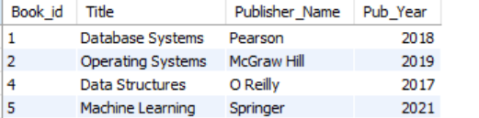

Book Authors table:

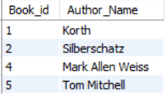

1. **Partition the BOOK table based on the year of publication. Demonstrate it’s working with a simple query**

SELECT Pub_Year, COUNT(*) AS Total_Books

FROM BOOK

GROUP BY Pub_Year;GROUP BY Pub_Year;

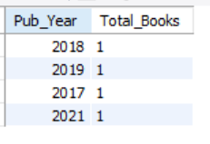

1. **Create a view of all books and it’s number of copies that are currently available in the Library**

CREATE VIEW Book_Availability AS

SELECT B.Book_id, B.Title, SUM(BC.No_of_Copies) AS Total_Copies

FROM BOOK B

JOIN BOOK_COPIES BC ON B.Book_id = BC.Book_id

GROUP BY B.Book_id, B.Title;

select * from book_Availability;

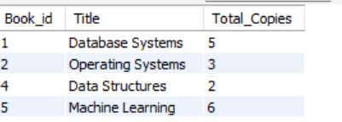

## 2) SALES ORDER DATABASE

### CREATION OF TABLES (DDL)

CREATE TABLE SALESMAN (

Salesman_id INT PRIMARY KEY,

Name VARCHAR(50),

City VARCHAR(50),

Commission FLOAT

);

CREATE TABLE CUSTOMER (

Customer_id INT PRIMARY KEY,

Cust_Name VARCHAR(50),

City VARCHAR(50),

Grade INT,

Salesman_id INT,

FOREIGN KEY (Salesman_id) REFERENCES SALESMAN(Salesman_id)

);

CREATE TABLE ORDERS (

Ord_No INT PRIMARY KEY,

Purchase_Amt FLOAT,

Ord_Date DATE,

Customer_id INT,

Salesman_id INT,

FOREIGN KEY (Customer_id) REFERENCES CUSTOMER(Customer_id),

FOREIGN KEY (Salesman_id) REFERENCES SALESMAN(Salesman_id)

);

### INSERTING INTO TABLES (DML)

INSERT INTO SALESMAN VALUES

(1000, 'John', 'Bangalore', 0.15),

(1001, 'Alice', 'Delhi', 0.12),

(1002, 'Bob', 'Bangalore', 0.10),

(1003, 'Charlie', 'Mumbai', 0.18),

(1004, 'David', 'Kolkata', 0.20);

-- INSERT INTO CUSTOMER

INSERT INTO CUSTOMER VALUES

(2000, 'Amit', 'Bangalore', 200, 1000),

(2001, 'Sita', 'Bangalore', 250, 1000),

(2002, 'Ravi', 'Delhi', 150, 1001),

(2003, 'Meera', 'Delhi', 300, 1001),

(2004, 'Ramesh', 'Mumbai', 180, 1003),

(2005, 'Sunita', 'Kolkata', 210, 1004);

-- INSERT INTO ORDERS

INSERT INTO ORDERS VALUES

(3000, 5000, '2024-03-01', 2000, 1000),

(3001, 7000, '2024-03-01', 2001, 1000),

(3002, 3000, '2024-03-02', 2002, 1001),

(3003, 8000, '2024-03-02', 2003, 1001),

(3004, 4500, '2024-03-03', 2004, 1003),

(3005, 6000, '2024-03-03', 2005, 1004);

### QUERIES

1. **Count the customers with grades above Bangalore’s average.**

SELECT COUNT(*) AS count_above_bangalore_avg

FROM CUSTOMER

WHERE GRADE > (SELECT AVG(GRADE)

FROM CUSTOMER WHERE CITY = 'BANGALORE');



1. **Find the names and numbers of all salesman who had more than one customer**

SELECT Name

FROM SALESMAN

WHERE Salesman_id IN (

SELECT Salesman_id

FROM CUSTOMER

GROUP BY Salesman_id

HAVING COUNT(*) > 1

);

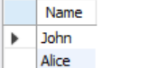

1. **List all the salesman and indicate those who have and don’t have customers in their cities (use UNION operation)**

SELECT S.Salesman_id, S.Name, 'Has Customer' AS Status

FROM SALESMAN S

WHERE S.Salesman_id IN (

SELECT C.Salesman_id

FROM CUSTOMER C

WHERE C.City = (SELECT City FROM SALESMAN WHERE Salesman_id = C.Salesman_id)

)

UNION

SELECT S.Salesman_id, S.Name, 'No Customer' AS Status

FROM SALESMAN S

WHERE S.Salesman_id NOT IN (

SELECT C.Salesman_id

FROM CUSTOMER C

WHERE C.City = (SELECT City FROM SALESMAN WHERE Salesman_id = C.Salesman_id)

);

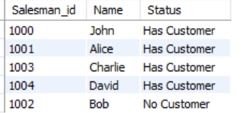

1. **Create a view that finds the salesman who has the customer with the highest order of a day.**

CREATE VIEW TopSalesman AS

SELECT O.Ord_Date, O.Purchase_Amt, S.Name AS Salesman_Name, C.Cust_Name AS Customer_Name

FROM ORDERS O

JOIN CUSTOMER C ON O.Customer_id = C.Customer_id

JOIN SALESMAN S ON O.Salesman_id = S.Salesman_id

WHERE O.Purchase_Amt = (SELECT MAX(Purchase_Amt) FROM ORDERS WHERE Ord_Date = O.Ord_Date);

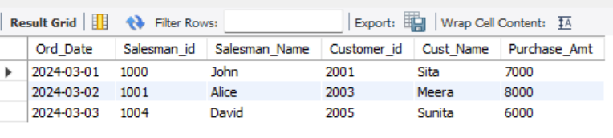

1. **Demonstrate the DELETE operation by removing salesman with id 1000. All his orders also be**

**deleted.**

DELETE FROM ORDERS

WHERE Salesman_id = 1000;

DELETE FROM SALESMAN

WHERE Salesman_id = 1000;

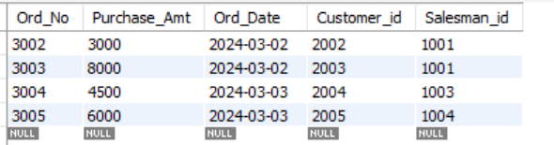

## 3) MOVIE DATABASE

### Creation of tables

CREATE TABLE ACTOR ( Act_id INT PRIMARY KEY, Act_Name VARCHAR(50), Act_Gender VARCHAR(10) );

CREATE TABLE DIRECTOR ( Dir_id INT PRIMARY KEY, Dir_Name VARCHAR(50), Dir_Phone VARCHAR(15) );

CREATE TABLE MOVIES ( Mov_id INT PRIMARY KEY, Mov_Title VARCHAR(100), Mov_Year INT, Mov_Lang

VARCHAR(20), Dir_id INT REFERENCES DIRECTOR(Dir_id) ON DELETE CASCADE);

CREATE TABLE MOVIE_CAST ( Act_id INT REFERENCES ACTOR(Act_id) ON DELETE CASCADE, Mov_id

INT REFERENCES MOVIES(Mov_id) ON DELETE CASCADE, Role VARCHAR(50), PRIMARY KEY (Act_id,

Mov_id) );

CREATE TABLE RATING ( Mov_id INT REFERENCES MOVIES(Mov_id) ON DELETE CASCADE, Rev_Stars

INT );

### Insertion of Tuples

INSERT INTO ACTOR VALUES

(1, 'Robert Downey Jr.', 'Male'),

(2, 'Scarlett Johansson', 'Female'),

(3, 'Chris Hemsworth', 'Male'),

(4, 'Leonardo DiCaprio', 'Male'),

(5, 'Emma Watson', 'Female'), (6, 'Tom Hanks', 'Male'),

(7, 'Angelina Jolie', 'Female'),

(8, 'Brad Pitt', 'Male');

INSERT INTO DIRECTOR VALUES

(1, 'ABCD', '1234567890'),

(2, 'XYZ', '9876543210'),

(3, 'Christopher Nolan', '5555555555'),

(4, 'Steven Spielberg', '6666666666'),

(5, 'James Cameron', '7777777777'),

(6, 'Martin Scorsese', '8888888888'),

(7, 'Quentin Tarantino', '9999999999'),

(8, 'Tim Burton', '4444444444'),

(10, 'XYZ', '1234567890');

INSERT INTO MOVIES VALUES

(1, 'Inception', 2010, 'English', 1),

(2, 'Avengers', 2012, 'English', 1),

(3, 'Titanic', 1997, 'English', 2),

(4, 'Interstellar', 2014, 'English', 3),

(5, 'Joker', 2019, 'English', 4),

(6, 'Fight Club', 1999, 'English', 5),

(7, 'Pulp Fiction', 1994, 'English', 6),

(8, 'The Dark Knight', 2008, 'English', 7),

(9, 'Movie XYZ1', 2020, 'English', 10),

(10, 'Movie XYZ2', 2021, 'English', 10);

INSERT INTO MOVIE_CAST VALUES

(1, 1, 'Lead Role'),

(1, 2, 'Supporting'),

(2, 1, 'Supporting'), (2, 2, 'Heroine'),

(2, 3, 'Guest Role'),

(3, 2, 'Hero'),

(3, 4, 'Lead Role'),

(4, 2, 'Villain'),

(4, 5, 'Supporting'),

(4, 6, 'Villain'),

(5, 3, 'Lead Role'),

(5, 7, 'Guest Role'),

(6, 4, 'Supporting'),

(7, 5, 'Guest Role'),

(8, 6, 'Supporting');

INSERT INTO RATING VALUES

(1, 5),

(2, 4),

(3, 5),

(4, 3),

(5, 4),

(6, 5),

(7, 4),

(8, 5),

(9, 3),

(10, 4);

### QUERIES

1. **List the titles of all the movies directed by ‘ABCD’**

SELECT Mov_Title FROM MOVIES

WHERE Dir_id = (SELECT Dir_id FROM DIRECTOR WHERE Dir_Name = 'ABCD');

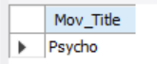

1. **Find the movie names where one or more actors acted in two or more movies**

SELECT Mov_Title

FROM MOVIES

WHERE Mov_id IN (

SELECT Mov_id

FROM MOVIE_CAST

WHERE Act_id IN (

SELECT Act_id

FROM MOVIE_CAST

GROUP BY Act_id

HAVING COUNT(DISTINCT Mov_id) >= 2

)

);

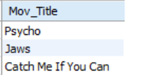

1. **List all the actors who acted in a movie before 2000 and also in a movie after 2015 (use JOIN**

**operation)**

SELECT Act_Name

FROM ACTOR

WHERE Act_id IN (

SELECT Act_id

FROM MOVIE_CAST MC

JOIN MOVIES M ON MC.Mov_id = M.Mov_id

WHERE M.Mov_Year < 2000

)

AND Act_id IN (

SELECT Act_id

FROM MOVIE_CAST MC

JOIN MOVIES M ON MC.Mov_id = M.Mov_id

WHERE M.Mov_Year > 2015

);

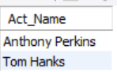

1. **Find the titles of movies and number of stars for each movie that has at least one rating and**

**find the highest number of stars that movie received. Sort the result my movie title.**

SELECT MOVIES.Mov_Title, MAX(RATING.Rev_Stars) AS Max_Rev_Stars

FROM MOVIES

JOIN RATING ON MOVIES.Mov_id = RATING.Mov_id

GROUP BY MOVIES.Mov_Title

ORDER BY MOVIES.Mov_Title;  
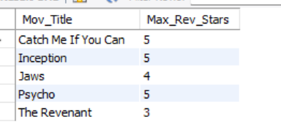

1. **Update rating of all movies directed by ‘XYZ’ to 5.**

UPDATE RATING

SET Rev_Stars = 5

WHERE Mov_id IN (

SELECT MOVIES.Mov_id

FROM MOVIES

JOIN DIRECTOR ON MOVIES.Dir_id = DIRECTOR.Dir_id

WHERE DIRECTOR.Dir_Name = 'Steven Spielberg'

);

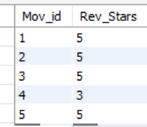

## 4) COLLEGE DATABASE

**Creation of tables:**

CREATE TABLE STUDENT (

USN VARCHAR(20) PRIMARY KEY,

SName VARCHAR(100),

Address VARCHAR(255),

Phone VARCHAR(15),

Gender VARCHAR(10)

);

CREATE TABLE SEMSEC (

SSID INT PRIMARY KEY,

Sem INT,

Sec VARCHAR(1)

);

CREATE TABLE CLASS (

USN VARCHAR(20),

SSID INT,

PRIMARY KEY (USN, SSID),

FOREIGN KEY (USN) REFERENCES STUDENT(USN),

FOREIGN KEY (SSID) REFERENCES SEMSEC(SSID)

);

CREATE TABLE SUBJECT (

Subcode VARCHAR(10) PRIMARY KEY,

Title VARCHAR(100),

Sem INT,

Credits INT

);

CREATE TABLE IAMARKS (

USN VARCHAR(20),

Subcode VARCHAR(10),

SSID INT,

Test1 INT,

Test2 INT,

Test3 INT,

PRIMARY KEY (USN, Subcode, SSID),

FOREIGN KEY (USN) REFERENCES STUDENT(USN),

FOREIGN KEY (Subcode) REFERENCES SUBJECT(Subcode),

FOREIGN KEY (SSID) REFERENCES SEMSEC(SSID)

);

INSERTION INTO ROWS

INSERT INTO STUDENT VALUES

('1BI15CS101', 'Arun Kumar', 'Bangalore', '9876543210', 'Male'),

('1BI19CS112', 'Sunita Patel', 'Mysore', '9876543212', 'Female'),

('1BI19CS113', 'Vikram Singh', 'Delhi', '9876543213', 'Male'),

('1BI15CS116', 'Sameer Khan', 'Mumbai', '9876543216', 'Male'),

('1BI15CS123', 'Swati Gupta', 'Pune', '9876543223', 'Female');

-- Insert data into SEMSEC table

INSERT INTO SEMSEC VALUES

(1, 1, 'A'),

(12, 4, 'C'),

(22, 8, 'A'),

(23, 8, 'B'),

(24, 8, 'C');

-- Insert data into CLASS table

INSERT INTO CLASS VALUES

('1BI15CS101', 1),

('1BI19CS112', 12),

('1BI19CS113', 12),

('1BI15CS116', 22),

('1BI15CS123', 24);

-- Insert data into SUBJECT table

INSERT INTO SUBJECT VALUES

('CS101', 'Introduction to Programming', 1, 4),

('CS104', 'Database Management Systems', 4, 4),

('CS105', 'Operating Systems', 4, 4),

('CS110', 'Artificial Intelligence', 8, 4),

('CS111', 'Machine Learning', 8, 4);

-- Insert data into IAMARKS table

INSERT INTO IAMARKS VALUES

('1BI15CS101', 'CS101', 1, 18, 19, 17),

('1BI19CS112', 'CS104', 12, 18, 19, 15),

('1BI19CS113', 'CS105', 12, 15, 17, 19),

('1BI15CS116', 'CS110', 22, 19, 18, 20),

('1BI15CS123', 'CS111', 24, 14, 16, 15);

-- Add FinalIA column to IAMARKS table

ALTER TABLE IAMARKS ADD COLUMN FinalIA INT;

-- Update FinalIA values

UPDATE IAMARKS

SET FinalIA = (

CASE

WHEN Test1 <= Test2 AND Test1 <= Test3 THEN (Test2 + Test3) / 2

WHEN Test2 <= Test1 AND Test2 <= Test3 THEN (Test1 + Test3) / 2

WHEN Test3 <= Test1 AND Test3 <= Test2 THEN (Test1 + Test2) / 2

END

);

### QUERIES

1. **List all the student details studying in the fourth semester 'C' section:**

SELECT *

FROM STUDENT

WHERE USN IN (

SELECT USN

FROM CLASS

WHERE SSID IN (

SELECT SSID

FROM SEMSEC

WHERE Sem = 4 AND Sec = 'C'

)

);

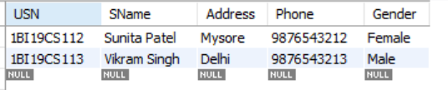

1. **Compute the total number of male and female students in each semester and each section:**

SELECT SS.Sem, SS.Sec, S.Gender, COUNT(*) AS Count

FROM STUDENT S

JOIN CLASS C ON S.USN = C.USN

JOIN SEMSEC SS ON C.SSID = SS.SSID

GROUP BY SS.Sem, SS.Sec, S.Gender

ORDER BY SS.Sem, SS.Sec;

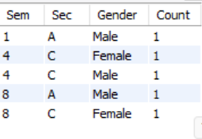

1. **Create a view of Test1 Marks of student USN '1XX1234' in all subjects:**

CREATE VIEW Student_1BI15CS101_Test1 AS

SELECT S.Subcode, S.Title, IA.Test1

FROM IAMARKS IA

JOIN SUBJECT S ON IA.Subcode = S.Subcode

WHERE IA.USN = '1BI15CS101';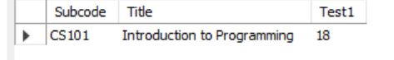

**5. Categorize students based on the specified criteria for 8th semester A, B, and C sections:**

SELECT IA.USN, IA.Subcode, IA.FinalIA,

CASE

WHEN IA.FinalIA BETWEEN 17 AND 20 THEN 'Outstanding'

WHEN IA.FinalIA BETWEEN 12 AND 16 THEN 'Average'

WHEN IA.FinalIA < 12 THEN 'Weak'

END AS Category

FROM IAMARKS IA

WHERE IA.SSID IN (

SELECT SSID

FROM SEMSEC

WHERE Sem = 8 AND Sec IN ('A', 'B', 'C')

)

ORDER BY IA.USN, IA.Subcode;

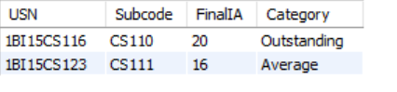);

## 5) COMPANY DATABASE

**Creation of Tables:**

create database j_db;

use j_db;

CREATE TABLE EMPLOYEE (

SSN INT PRIMARY KEY,

Name VARCHAR(100) NOT NULL,

Address VARCHAR(255),

Sex CHAR(1),

Salary DECIMAL(10,2) CHECK (Salary > 0),

SuperSSN INT NULL,

DNo INT NULL

);

CREATE TABLE DEPARTMENT (

DNo INT PRIMARY KEY,

DName VARCHAR(100) UNIQUE NOT NULL,

MgrSSN INT UNIQUE NULL,

MgrStartDate DATE

);

-- Now add the foreign key constraints after both tables exist

ALTER TABLE EMPLOYEE ADD CONSTRAINT FK_Emp_Dept FOREIGN KEY (DNo) REFERENCES DEPARTMENT(DNo) ON DELETE CASCADE;

ALTER TABLE DEPARTMENT ADD CONSTRAINT FK_Dept_Mgr FOREIGN KEY (MgrSSN) REFERENCES EMPLOYEE(SSN) ON DELETE SET NULL;

-- Creating DLOCATION Table

CREATE TABLE DLOCATION (

DNo INT,

DLoc VARCHAR(100),

PRIMARY KEY (DNo, DLoc),

FOREIGN KEY (DNo) REFERENCES DEPARTMENT(DNo) ON DELETE CASCADE

);

-- Creating PROJECT Table

CREATE TABLE PROJECT (

PNo INT PRIMARY KEY,

PName VARCHAR(100) UNIQUE NOT NULL,

PLocation VARCHAR(100),

DNo INT,

FOREIGN KEY (DNo) REFERENCES DEPARTMENT(DNo) ON DELETE CASCADE

);

CREATE TABLE WORKS_ON (

SSN INT,

PNo INT,

Hours DECIMAL(5,2) CHECK (Hours >= 0),

PRIMARY KEY (SSN, PNo),

FOREIGN KEY (SSN) REFERENCES EMPLOYEE(SSN) ON DELETE CASCADE,

FOREIGN KEY (PNo) REFERENCES PROJECT(PNo) ON DELETE CASCADE

);

-- Inserting Sample Data

INSERT INTO DEPARTMENT (DNo, DName, MgrSSN, MgrStartDate) VALUES

(1, 'Accounts', NULL, '2020-01-01'),

(2, 'IT', NULL, '2021-06-15');

INSERT INTO EMPLOYEE (SSN, Name, Address, Sex, Salary, SuperSSN, DNo) VALUES

(101, 'John Scott', '123 Main St', 'M', 60000, NULL, 1),

(102, 'Alice Brown', '456 Oak St', 'F', 75000, NULL, 2),

(103, 'Michael Scott', '789 Pine St', 'M', 80000, NULL, 1);

UPDATE DEPARTMENT SET MgrSSN = 103 WHERE DNo = 1; -- Assigning Michael Scott as Manager of Accounts

INSERT INTO DLOCATION (DNo, DLoc) VALUES

(1, 'New York'),

(2, 'San Francisco');

INSERT INTO PROJECT (PNo, PName, PLocation, DNo) VALUES

(201, 'IoT', 'New York', 1),

(202, 'AI Research', 'San Francisco', 2);

INSERT INTO WORKS_ON (SSN, PNo, Hours) VALUES

(101, 201, 20),

(102, 202, 25),

(103, 201, 30);

**QUERIES:**

1. **Make a list of all project numbers for projects that involve an employee whose last name is 'Scott', either as a worker or as a manager of the department that controls the project.**

SELECT DISTINCT P.PNo

FROM PROJECT P

WHERE P.DNo IN (

SELECT D.DNo

FROM DEPARTMENT D

JOIN EMPLOYEE E ON D.MgrSSN = E.SSN

WHERE E.Name LIKE '%Scott'

)

OR P.PNo IN (

SELECT W.PNo

FROM WORKS_ON W

JOIN EMPLOYEE E ON W.SSN = E.SSN

WHERE E.Name LIKE '%Scott'

);

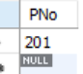

1. **Show the resulting salaries if every employee working on the 'IoT' project is given a 10 percent raise.**

SELECT E.SSN, E.Name, E.Salary AS CurrentSalary,

E.Salary * 1.10 AS NewSalary,

E.Salary * 0.10 AS SalaryIncrease

FROM EMPLOYEE E

JOIN WORKS_ON W ON E.SSN = W.SSN

JOIN PROJECT P ON W.PNo = P.PNo

WHERE P.PName = 'IoT';

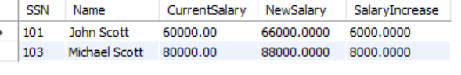

1. **Find the sum of the salaries of all employees of the 'Accounts' department, as well as the maximum salary, the minimum salary, and the average salary in this department.**

SELECT SUM(Salary) AS TotalSalary,

MAX(Salary) AS MaximumSalary,

MIN(Salary) AS MinimumSalary,

AVG(Salary) AS AverageSalary

FROM EMPLOYEE

WHERE DNo = (SELECT DNo FROM DEPARTMENT WHERE DName = 'Accounts');

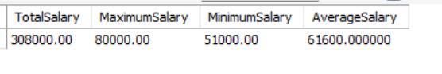

1. **Retrieve the name of each employee who works on all the projects controlled by department number 5 (use NOT EXISTS operator).**

SELECT E.Name

FROM EMPLOYEE E

WHERE NOT EXISTS (

SELECT P.PNo

FROM PROJECT P

WHERE P.DNo = 5 AND NOT EXISTS (

SELECT W.PNo

FROM WORKS_ON W

WHERE W.PNo = P.PNo AND W.SSN = E.SSN

)

)

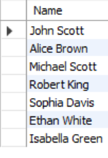

**5. For each department that has more than five employees, retrieve the department number and the number of its employees who are making more than Rs.6,00,000.**

SELECT D.DNo,

(SELECT COUNT(*)

FROM EMPLOYEE E2

WHERE E2.DNo = D.DNo AND E2.Salary > 600000) AS HighSalaryCount

FROM DEPARTMENT D

WHERE (SELECT COUNT(*)

FROM EMPLOYEE E1

WHERE E1.DNo = D.DNo) > 5;

